|  |  |  |
| --- | --- | --- |
| **Country** | **Obs in the survey** | **Obs. in the analysis** |
| Austria | 1039 | 830 |
| Belgium | 1029 | 970 |
| Bulgaria | 1041 | 626 |
| Croatia | 1016 | 904 |
| Cyprus | 504 | 411 |
| Czech Republic | 1019 | 729 |
| Denmark | 1019 | 839 |
| Estonia | 999 | 520 |
| Finland | 1006 | 807 |
| France | 1029 | 797 |
| Germany | 1539 | 1200 |
| Greece | 1014 | 854 |
| Hungary | 1023 | 900 |
| Ireland | 1067 | 928 |
| Italy | 1022 | 905 |
| Latvia | 1003 | 687 |
| Lithuania | 1001 | 704 |
| Luxembourg | 502 | 399 |
| Malta | 507 | 397 |
| Netherlands | 1022 | 883 |
| Poland | 1013 | 710 |
| Portugal | 1012 | 863 |
| Romania | 1053 | 869 |
| Slovakia | 1076 | 810 |
| Slovenia | 1003 | 874 |
| Spain | 1011 | 820 |
| Sweden | 1034 | 890 |
| United Kingdom | 1052 | 852 |
| **Total** | **27655** | **21978** |

Sociologists suggest that we cannot guarantee that the distance between 1 = “Totally agree” and 2 = “Tend to agree” is the same as 3 = “Not very important” and 4= “Tot at all important”. However, Norman (2010) affirms that “if the numbers are reasonably distributed, we can make inferences about their means, differences or whatever” (p. 629). Therefore, Shapiro-Test is computed for these Likert scale ordinal variable:

“Public opinion on climate change is multidimensional, dynamic, and differentiated” (Shwom et al., 2015, p. 269). Climate change opinion is one of the major issues that is continuing to grow in intensity and complexity.

Scholars suggest other relevant variables for understanding both risk perception and the willingness to act in an environmentally benign manner (0’conner, p.462)

**Analysis**

The following section illustrates the different steps undertaken to obtain a prediction model for pro-environmental action. In particular, the first step consists of Exploratory Data Analysis, in order to investigate climate change attitudes. Then, the best fitting models tested to predict the final price are presented.

**Exploratory Data Analysis**

Climate change attitudes do not vary only between countries but also between citizens in the same country (Xie et al., 2019). As you can see in the figure 1, the percentage of those who believe that climate change is the single most serious problem varies significantly according to country. For example, Bulgaria and Croatia obtain the smaller percentage, that is 11% of citizens who think climate change is the single most serious problem. On the contrary, about 1 out 2 Sweden’s citizen indicated climate change.

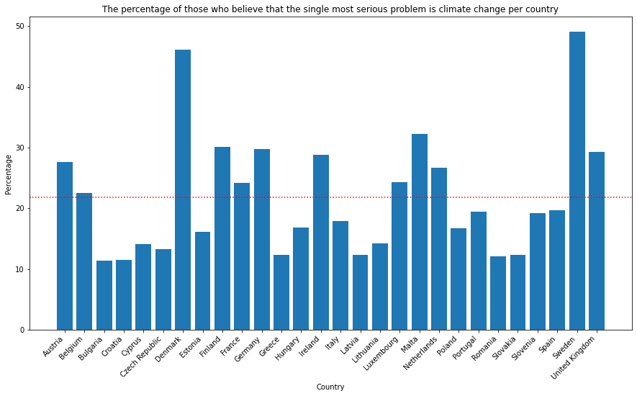

Figure 4: Single Most Serious Problem

Another interesting example is the difference in the climate change risk perception. As you can see in the figure 2, about half of citizens of Malta and Luxemburg declared that they are extremely worrying about the phenomenon studied.

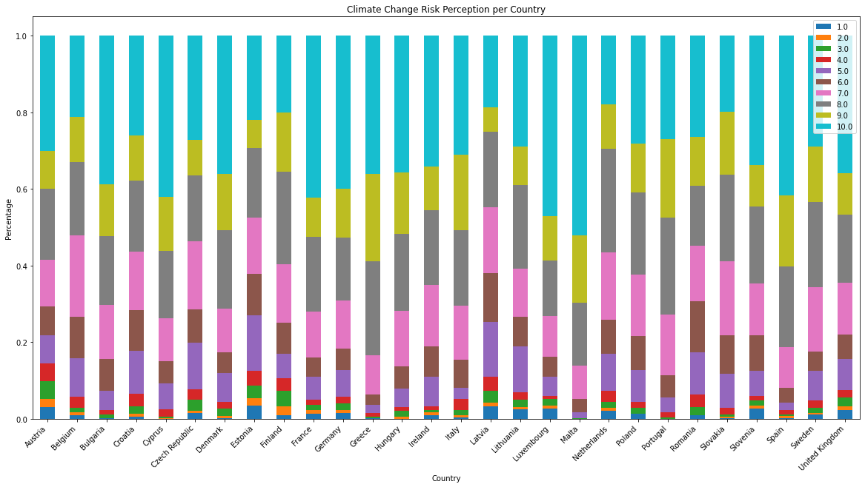

Figure 5: Climate Change Risk Perception

Attitudes among countries could be so vary since they are influenced by different contextual factors (Echavarren et al., 2019; Krajhanzl, 2010). According to Echavarren and colleagues (2019), opinion, perception and behavior could change due to different natural hazards and political context. For example water deficit or temperature growth regarding natural hazards and the “level of environmentalism in the political arena of a given country” (Echavarren et al., 2019, p. 815) for political variables. These macro-variables should be significant mediators in explaining risk perception or pro-environmental behavior. Some indexes are considered with the sole purpose of remembering that they could affect and moderate the phenomenon studied. Then, they are not inserted in the final models since only multilevel method could be adopted. In addition, the aim of the research is not to evidence national or cultural differences, but on the contrary, it is to find patterns at individual levels, regardless of the place of origin. However, these differences at the macro levels are presented.

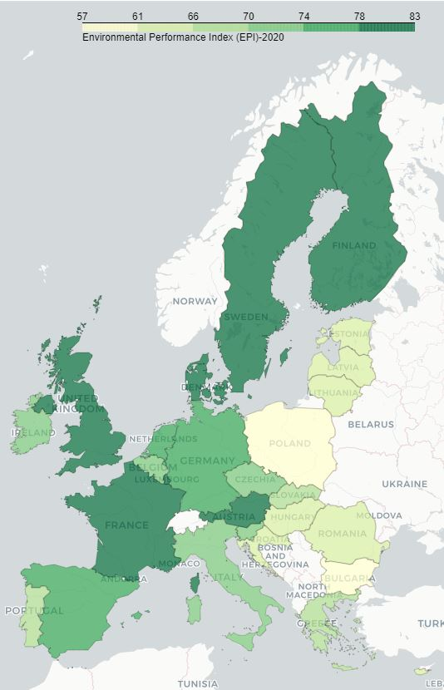For the natural hazards the 2020 Environmental Performance Index (EPI) is used (the 2019 EPI is not available in order to use the same data of year of the survey) (Yale Center for Environmental Law & Policy, 2020). EPI quantifies numerically environmental health and ecosystem vitality around the world. Some indicators that composed the index are: air pollution, drinking water quality, species protection. These phenomena could be positively affect climate change concerns and opinion (Echavarren et al., 2019). In fact, citizens should perceive biodiversity loss or temperature increases, leading to greater apprehension. The figure 3 shows the score across European Union (EU). The best score is obtained from Denmark, while the worst from Bulgaria.

Figure 6: The 2020 EPI

For the political context the 2019 Climate Change Policy Performance is selected, which is a mesarument of national and international climate policies (Burck, 2018) developed by organisation Germanwatch. It is one of the indicators that belongs to the Climate Change Performance Index (CCPI). The indicator constitutes the measurements taken by governments in order to reduce current level of GHG emissions per capita or the use of renewavle energy. Briefly it is defined as a measure of countries’ progress and their capacity to climate protection (Burck, 2018). In the Climate Change Policy the record goes to Portugal and Bulgaria gets the lowest score in all European Union, as the figure 4 shows.

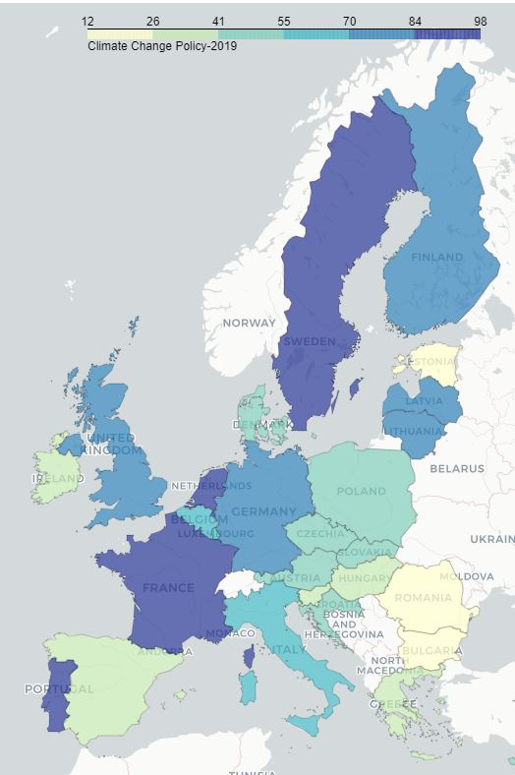According to scholars (Echavarren et al., 2019; van der Linden, 2015) socio-cultural context influces individual attitudes towards climate change concerns. Therefore, the notable diferencess in attitudes across coutries should be also due to these indicators. In fact, “sociological research suggests that contextual factors and processes can be powerful forces shaping how individuals and communities engage with the issue” (Lee et al., 2015, p. 1014). There are different ecological tax reforms or cultural habits that affect and shape individual climate change attitudes and behavior.

Figure 7:The 2019 Climate Change Policy

In this way, It is important to remember that these macro-factors should have an effect also in individual preferences.